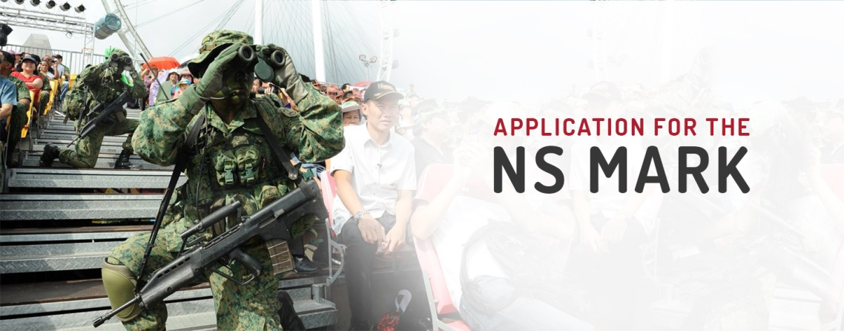
Make a difference with your support.
Apply for the NS Mark accreditation today.

Name of Company / Organisation: *Mandatory

Nature of Business:

Head of Entity (or equivalent):

Entity Type: *Delete as appropriate

Small and Medium Enterprise (SME) / Large Company / Organisation

Name of Point of Contact: *Mandatory

Appointment Held: *Mandatory

Contact Number (Primary): *Mandatory

Contact Number (Alternate):

Email Address: *Mandatory

We encourage you to pledge your support for National Service by making the declaration of support as follows:

Declaration of Support

We acknowledge that National Service (NS) is the cornerstone of our nation’s peace and security. Our National Servicemen (NSmen) fulfil their responsibilities dutifully to provide a safe and secure environment for Singapore and Singaporeans to grow and thrive.

We recognise the importance of National Service and accept that it is shared responsibilities. Our support and recognition of our NSmen’s contributions will strengthen their commitment to serve.

Therefore, we pledge that:

- We will honour and uphold our duty as employers of NSmen as laid out in the Enlistment Act (Cap 93, Part VI)

- We will recognise and appreciate the skills acquired and values inculcated in our NSmen through National Service.

- We will actively support our NSmen to manage their National Service commitments.

- We will readily commit our civil assets and services in support of Total Defence and support our nation in national crises or emergencies.

We declare our support. *Please tick box to declare support.

Signature/Date

